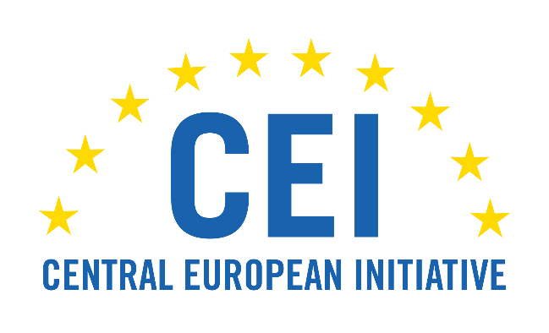
MEETING OF THE GENERAL COMMITTEE ON CULTURAL AFFAIRS
OF THE CENTRAL EUROPEAN INITIATIVE PARLIAMENTARY DIMENSION
27 September 2022, Kraków

Summary by the Chair of the General Committee on Culture of the Central European Initiative Parliamentary Dimension Mr. Tomasz Głogowski

The General Committee on Culture of the Central European Initiative Parliamentary Dimension convened in Kraków, Poland, to discuss the administration and protection of sites of the UNESCO World Heritage List in the Central European Initiative region. The meeting was attended by delegations from Albania, Czechia, Hungary, Italy, Poland, Romania, Serbia and Ukraine as well as by the representatives of the CEI Executive Secretariat.

The participants emphasized that the sites from the UNESCO World Heritage List are of particular value for the cultural heritage of all mankind. The importance of these objects goes beyond the history and tradition of one country. Therefore, it is important to exchange experiences in managing them and making them widely available. This creates cultural, economic and social opportunities that should be exploited for the dissemination and preservation of cultural heritage.

Popularisation of the UNESCO World Heritage sites get people acquainted with the richness of other cultures, teach tolerance and contribute to strengthening good neighbourly relations.

The participants highlighted the need of the appropriate legislative solutions ensuring the protection, administration and revitalization of sites inscribed on the World Heritage List. Maintaining a balance between the protection of a monument and its accessibility is of the crucial importance. One of the discussed ideas was the introduction of a unified way of marking objects from the UNESCO World Heritage List.

The need to combine the efforts of private and state entities and their coordination in ensuring the protection and ongoing administration of UNESCO sites was indicated. The participants emphasised the role of national parliaments in creating appropriate legislative solutions and strengthening cultural diplomacy on the parliamentary level.

Much space in the discussion was devoted to the destruction of cultural heritage sites located on the territory of Ukraine, including those inscribed on the UNESCO World Heritage List, as a result of the war unleashed by Russian Federation. The Ukrainian delegation presented the scale of the barbarian destruction of Ukrainian cultural objects caused by Russian bombings. The participants expressed full support to the Ukrainian people in their struggle for the freedom against the Russian aggressor and for the security on the European continent. The representatives of member states to PD CEI emphasized the need for the international community to prepare and implement aid programmes aiming at reconstruction of Ukraine, and restoration of the Ukrainian monuments and cultural sites. Ukrainian delegation asked for the international support in order to include the Historic Centre of the Port City of Odessa on the UNESCO World Heritage List.

The participants agreed to continue in the future the discussion about the administration and protection of sites of the UNESCO World Heritage List, at the CEI Parliamentary Dimension format.

