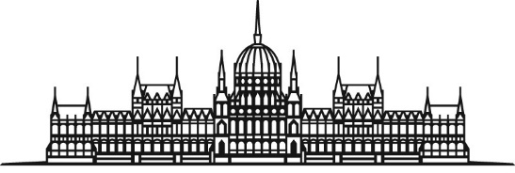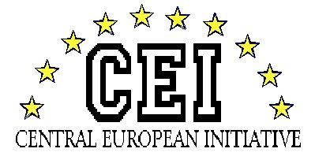
HUNGARIAN NATIONAL ASSEMBLY Session of the CEI-PD Parliamentary Committee
28-30 March 2019, Budapest

PROGRAMME

Meeting of the General Committee on Cultural Affairs:
“New perspectives of cultural cooperation”
Budapest, 28-30 March 2019

Thursday, 28 March 2019

Arrival of delegations to the Hotel President Budapest
Budapest, 1054 Budapest, Hold u. 3-5.

18.30 Welcome reception hosted by Mr. Richárd HÖRCSIK, Head of the Hungarian Delegation of the PD CEI

Friday, 29 March 2019

8.30 Departure from the Hotel to the Parliament

09.00 Registration of participants

9.30 Opening of the CEI-PD Committee Meeting
Venue: Delegation Hall of the Parliament

Welcome address of Dr. Márta MÁTRAI, the Deputy of the Speaker of the Hungarian National Assembly

Opening speech by Mr. Antal NIKOLETTI, the Deputy Secretary General of the CEI
9.45 Adoption of the draft agenda

Introductory remarks of Mr. Richárd HÖRCSIK, Head of Hungarian Delegation of the PD CEI

10.00 Discussion on Cross Border Tourism development programmes and their perspectives within CEI countries

Keynote speaker 1: Dávid FARKAS, deputy executive director of the Hungarian Tourism Agency
Keynote speaker 2: Péter BÁGYI, head of the former northern region of the Association of Hungarian Hotels and Restaurants

Debate

11.15 Family photo and coffee break
Venue: Room 38, Main floor

11.30 Discussion on the new cultural-touristic thematic: the pilgrim routes in CEI countries

Keynote speaker: Zoltán FÜRJES, Deputy Minister of State for Relations with the Church and Ethnic Communities and for Support for Persecuted Christians, Prime Minister’s Office

Debate

12.15 Debate and adoption of the Conclusions

Closure of the Meeting

12.30 Buffet lunch
Venue: Room 37, Main floor
13.30 Guided tour in the Parliament (optional)

14.15 Departure to Sárospatak by bus (optional)

17.45 Arrival to the Hotel
Venue: Hotel Bodrog
3950 Sárospatak, Rákóczi út 58.

19.15 Departure from the Hotel to the Renaissance Kitchen of the Rákóczi Castle

19.30 Dinner and wine tasting hosted by Mr. Richárd HÖRCSIK, Head of the Hungarian Delegation to the CEI–PD
Venue: Renaissance Kitchen of the Rákóczi Castle
22.00 Return to Hotel Bodrog (by bus)
Saturday, 30 March 2019

9.15 Departure from the Hotel to the cultural programme

09.30 Cultural programme
Guided tour at the Rákóczi Castle

11.30 Departure to Telkibánya (by bus)

12.30 Lunch and pálinka tasting hosted by Mr. Richárd HÖRCSIK, Head of the Hungarian Delegation to the CEI–PD
Venue: Aranygombos Inn
(Telkibánya, Múzeum út 3.)

14.15 Departure to Budapest

17.00 Arrival to the Hotel President Budapest
Individual Departures of the Delegations

